**TWO DAY WORKSHOP**

**ON**

**“REAL-TIME APPLICATIONS IN DATA**

**SCIENCE AND CYBER SECURITY”**

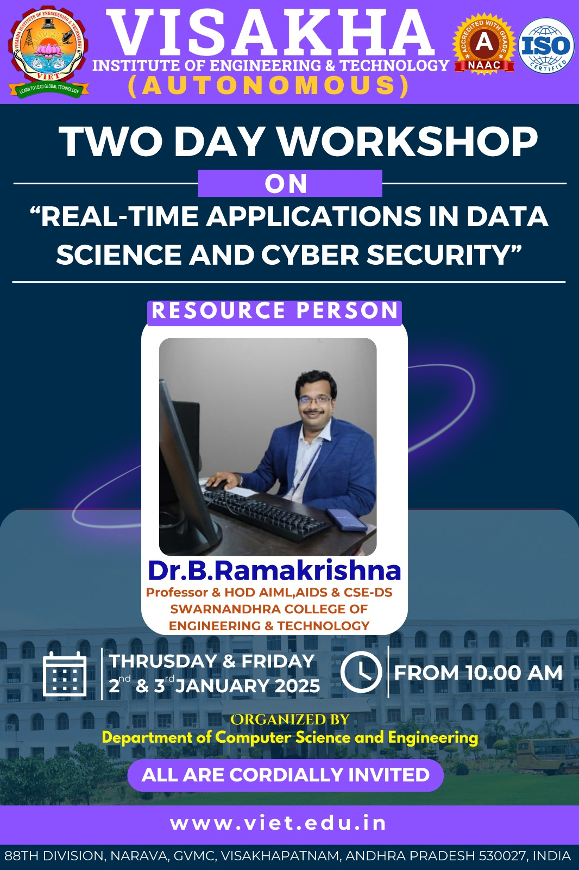

**Location**: Visakhapatnam, Nalgonda

Visakha Institute of Engineering and Technology College recently organized a grand two-day workshop on **Real-Time Applications in Data Science and Cyber Security**. The event took place on 2nd&3rd January 2025 at the college's campus in Gopalapatnam, Narava.

**Key Highlights:**

* **Chief Guest**: Dr. B. Ramakrishna, Head of Department (AIML, AIDS & CSE-DS) at Swarnandhra Engineering College.
* **Event Launch**: The program began with the lighting of the ceremonial lamp by Dr. B. Ramakrishna, marking the official start of the workshop.

Dr. Ramakrishna addressed the students of Computer Science and Engineering, sharing insights into the applications of Data Science and Cyber Security in various fields. He emphasized the importance of **practical knowledge** and **communication skills** in the rapidly evolving technological landscape.

**Key Takeaways from the Workshop:**

1. **Applications of Data Science**: Data Science has numerous real-world applications, and students were encouraged to explore these in depth.
2. **Cyber Security**: The importance of Cyber Security in protecting sensitive information and its growing demand across industries was discussed.
3. **Job Opportunities**: Dr. Ramakrishna outlined the wide range of job opportunities available in the fields of Data Science and Cyber Security and gave suggestions on how to pursue them.

**Acknowledgements:**

* Dr. B. Ramakrishna was felicitated by the **College Chairman, Mr. G. Satyanarayana**.
* The **College Principal, Dr. G.V. Pradeep Verma**, and **Dr. K. Tejaswini**, Head of the Computer Science Department, were also present at the event.
* The seminar was attended by department heads, faculty members, students, and staff.

